Name: Celebrate

Surname: Mashaba

Student number: ST10055395

Module name: HUMAN COMPUTER INTERACTION

Module code: HCIN6222

Assessment Type: POE

Group: 1

# INTRODUCTION

In today's interconnected world, fostering mental health support through digital platforms is imperative. HarmonyHaven is conceived as a pivotal website where individuals can access vital mental health resources, engage with knowledgeable professionals, join supportive communities, and obtain comprehensive information. This report delineates the strategic blueprint for the website's functionalities, emphasizing user-friendly design, immersive user experience, aesthetic design, diverse interaction types, community engagement, emotional resonance, and strict adherence to Web Content Accessibility Guidelines (WCAG) 2.0.

# 1.1 Functionality of the Mental Health Support Network Website:

1. **Client Enrolment and Profiles:**
   * **Description:** Users can create accounts and provide additional mental health details in their profiles.
   * **Explanation:** Personalization for users and effective resource connection.
2. **Search and Matching Framework:**
   * **Description:** Users can search for mental health experts, support groups, and resources based on various criteria.
   * **Explanation:** Facilitates quick access to relevant support based on individual needs.
3. **Client Surveys and Evaluations:**
   * **Description:** Users can read and leave reviews for mental health professionals and support groups.
   * **Explanation:** Enhances trust and transparency through shared experiences.
4. **Secure Messaging System:**
   * **Description:** Users can communicate privately with professionals and peers.
   * **Explanation:** Ensures confidentiality and direct interaction for guidance and support.
5. **Appointment Scheduling:**
   * **Description:** Users can book meetings with mental health professionals directly through the website.
   * **Explanation:** Simplifies the process of seeking professional help.
6. **Resource Library:**
   * **Description:** Curated content on mental health topics.
   * **Explanation:** An invaluable repository for users to enhance their mental health journey.
7. **Community Forums and Discussion Boards:**
   * **Description:** Platforms for users to engage, share experiences, and offer support.
   * **Explanation:** Fosters a sense of community and mutual aid.
8. **Emergency Contacts and Hotlines:**
   * **Description:** Quick access to local and national mental health hotlines.
   * **Explanation:** Ensures immediate assistance in crisis situations.

# 1.2 Usability Goals:

Usability Goal 1: Intuitive Navigation

* **Implementation:** Clear menu structure and labeled buttons for easy navigation.

Usability Goal 2: Clear Communication

* **Implementation:** Empathetic and concise language across the platform for clear instructions.

Usability Goal 3: User-Friendly Search Functionality

* **Implementation:** Prominently displayed search feature for quick access to resources.

Usability Goal 4: Mobile Responsiveness

* **Implementation:** Full responsiveness on diverse devices for seamless access.

Usability Goal 5: Accessibility Compliance

* **Implementation:** Adherence to WCAG 2.0 for inclusivity and accessibility.

Usability Goal 6: Engaging Visual Design

* **Implementation:** Inviting visuals and design for a positive user experience.

Usability Goal 7: Feedback Mechanism

* **Implementation:** Transparent feedback system for user actions.

Usability Goal 8: Streamlined Registration Process

* **Implementation:** Simplified and clear registration steps.

Usability Goal 9: Personalization Options

* **Implementation:** Customization for user preferences.

Usability Goal 10: Data Security and Privacy Assurance

* **Implementation:** Robust measures for user data security and confidentiality.

# 1.3 Desirable Aspects of User Experience:

Aspect 1: Empathetic Design

* **Implementation:** Soothing design elements for a welcoming environment.

Aspect 2: Responsive Design

* **Implementation:** Optimization for different devices for a seamless experience.

Aspect 3: Community Building

* **Implementation:** Highlighting success stories and user-generated content for community engagement.

Aspect 4: Gamification

* **Implementation:** Incorporating game-like elements for user motivation.

Aspect 5: Real-time Support

* **Implementation:** Immediate chat support for urgent assistance.

Aspect 6: Seamless Transitions

* **Implementation:** Smooth navigation for uninterrupted browsing.

Aspect 7: Curation

* **Implementation:** Tailored recommendations for enriched user experience.

# 1.4 Design Principles:

Design Principle 1: Consistency

* **Implementation:** Maintaining consistent branding elements.

Design Principle 2: Accessibility

* **Implementation:** Conformance to WCAG guidelines for inclusivity.

Design Principle 3: Intuitive Information Hierarchy

* **Implementation:** Clear organization of content for easy accessibility.

Design Principle 4: Minimalistic Interface

* **Implementation:** Clean and focused interface design.

Design Principle 5: Feedback and Affordance

* **Implementation:** Clear feedback for user interactions.

# 1.5 Interaction Types:

Interaction Type 1: Secure Messaging

* **Implementation:** Private communication channels for users and professionals.

Interaction Type 2: Appointment Booking

* **Implementation:** Direct appointment scheduling for user convenience.

Interaction Type 3: Community Forums

* **Implementation:** Moderated platforms for user engagement and support.

Interaction Type 4: Personal Journals

* **Implementation:** Private spaces for personal reflections and sharing.

Interaction Type 5: Virtual Support Groups

* **Implementation:** Remote support group sessions for broader accessibility.

# 1.6 Social Interactions:

Social Interaction 1: Community Forums

* **Implementation:** User engagement and support within community forums.

Social Interaction 2: Peer Messaging

* **Implementation:** Private messaging among users for confidential interactions.

Social Interaction 3: User Profiles and Bios

* **Implementation:** Customizable profiles for community connection.

Social Interaction 4: Activity Feeds

* **Implementation:** User-generated content for engagement.

Social Interaction 5: Support Group Chats

* **Implementation:** Real-time discussions within support groups.

Social Interaction 6: Peer-to-Peer Recommendations

* **Implementation:** User-driven recommendations for shared knowledge.

# 1.7 Emotional Interaction:

Emotional Interaction 1: Empathy and Supportive Language

* **Implementation:** Compassionate language for a supportive environment.

Emotional Interaction 2: Virtual Gestures

* **Implementation:** Features allowing users to express support virtually.

Emotional Interaction 3: Inspirational Content

* **Implementation:** Access to motivational content for encouragement.

# 1.8 Web Content Accessibility and Guidelines (WCAG) 2.0:

Accessibility Measure 1: Alt Text for Images

* **Implementation:** Descriptive alternative text for image comprehension.

Accessibility Measure 2: Keyboard Navigation

* **Implementation:** Keyboard accessibility for navigation.

Accessibility Measure 3: Contrast and Colour Accessibility

* **Implementation:** Compliance with contrast guidelines for readability.

Accessibility Measure 4: Headings and Structure

* **Implementation:** Proper hierarchical structure for screen reader support.

Accessibility Measure 5: ARIA Landmarks

* **Implementation:** Additional cues for screen reader navigation.

Accessibility Measure 6: Captions and Transcripts for Media

* **Implementation:** Inclusion of captions for audio

UPDATED THINGS

The recent updates on the HarmonyHaven website signify a substantial enhancement across crucial facets of the Mental Health Support Network. Notably, there's an expansion in functionalities, introducing features such as personalized client enrollment, refined search options, client feedback mechanisms, secure messaging, appointment scheduling, an enriched resource library, engaging community forums, and immediate access to emergency hotlines. These additions intend to provide users with a more tailored, secure, and comprehensive platform for their mental health needs. Furthermore, the updates encompass a detailed integration of usability goals, enriched user experience elements, diverse interaction types, deeper social engagements, emotional support features, and a steadfast adherence to the WCAG 2.0 standards. This comprehensive upgrade aims to create an inclusive, user-centric, and supportive online space for those seeking mental health support.

In addition, we're excited to introduce three new pages designed to better cater to our users' needs. The "Services" page now offers comprehensive insights into available support options, simplifying exploration to find the right fit for individual needs. Our "Appointment Scheduling" page facilitates easy connections with mental health professionals, allowing convenient scheduling of appointments, whether virtual or in-person. Lastly, the newly added "Contact Us" page streamlines communication, making it effortless for users to reach out with inquiries or feedback. These updates have been introduced to further streamline and support your journey toward improved mental well-being. We remain committed to being your reliable and supportive companion every step of the way.

# **CONCLUSION**

In conclusion, the creation of the Mental Health Support Network marks a significant milestone in the pursuit of accessible and compassionate mental health resources. By harnessing the capabilities of technology, we have established a platform that not only provides essential functionalities but also does so with a profound understanding of the sensitive nature of mental health support. Through careful consideration of usability goals, user experience, design principles, interaction types, social interactions, emotional engagement, and adherence to Web Content Accessibility Guidelines (WCAG) 2.0, we have crafted a space where individuals can seek and receive the support they require, while safeguarding their dignity and privacy. The incorporation of features such as user reviews, secure messaging, and a comprehensive resource library further enhances the platform's value, empowering users on their journey towards mental well-being. With an unwavering commitment to web accessibility, we ensure that the Mental Health Support Network remains an inclusive and welcoming space for all individuals, regardless of their abilities or disabilities. This platform stands as a testament to the transformative potential of technology in the realm of mental health advocacy, offering not only resources but also a community of understanding and support.

**Prototype**

[**https://harmoneyhaven.mydurable.com/**](https://harmoneyhaven.mydurable.com/)

<https://harmoneyhaven.mydurable.com/>

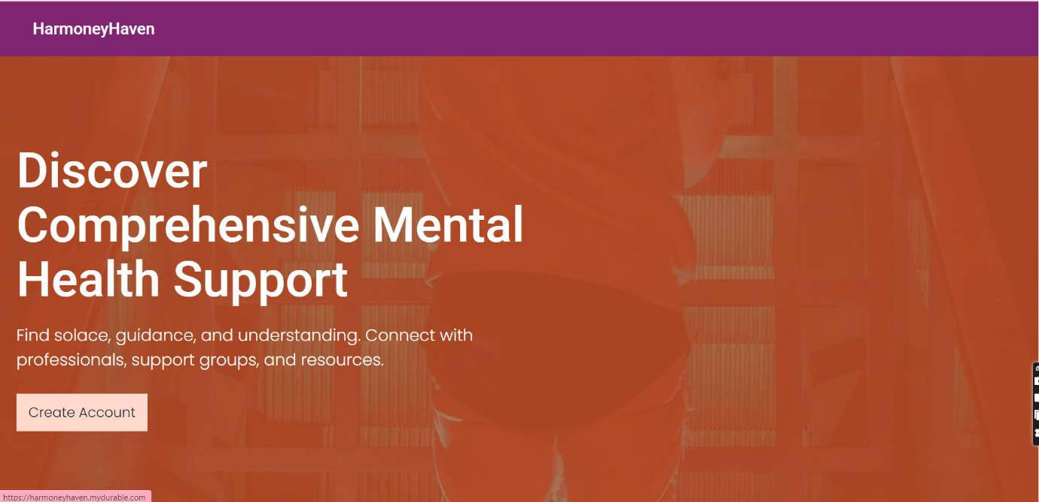

# References

AFZAL, F., 2023. *website-functionality.* [Online]   
Available at: https://wpsupportdesk.com/blog/website-functionality/  
[Accessed 24 SEPTEMBER 2023].

Anon., n.d. [Online]   
Available at: https://www.who.int/teams/mental-health-and-substance-use

Anon., n.d. [Online]   
Available at: https://byjus.com/biology/what-are-the-types-of-interactions-between-organisms/

Anon., n.d. [Online]   
Available at: https://www.w3.org/TR/UNDERSTANDING-WCAG20/complete

Anon., n.d. *literature.* [Online]   
Available at: https://www.interaction-design.org/literature/topics/usability  
[Accessed 25 SEPTEMVER 2023].

Delaney, J., 2021. [Online]   
Available at: https://paperform.co/blog/principles-of-design/  
[Accessed 26 SEPTEMBER 2023].

Hicklen, H., 2021. *website-functionality.* [Online]   
Available at: https://topdesignfirms.com/web-design/blog/website-functionality  
[Accessed 26 SEPTEMBER 2023].

IDLER, S., 2013. *Resources.* [Online]   
Available at: https://www.getfeedback.com/resources/ux/5-critical-aspects-user-experience/  
[Accessed 26 SEPTEMBER 2023].

Nielsen, J., 2012. *usability-101-introduction-to-usability.* [Online]   
Available at: https://www.nngroup.com/articles/usability-101-introduction-to-usability/  
[Accessed 26 SEPTEMBER 2023].